MONDAY, SEPT. 21st
At this point, we should be finished with all of the grayed-out sections and ready to start on our Summary of Design Evolution. Each day we’ve tackled about a half-dozen sections, and today will be the same. Tomorrow, we will submit our Rough Drafts for Peer Review, so make sure you have a complete report if you want to get feedback! (You need to have the report essentially complete.) Also today during class we will be testing our final prototype models to get the “official” measurement for your conclusions! Let’s get started!

Table of Contents
Abstract ………………………………………………………………………………………… #?
Introduction …………………………………………………………………………………… #?
Objective ……………………………………………………………………………………… #?
Initial Brainstorming …………………………………………………………………………… #?
Background Research (“Knowledge At Work”) …………………………………………….… #?
Design Parameters & Specifications …………………………………………………………… #?
Development of Computer Aided Design Model ……………………………………………… #?
Iteration 1 ……………………………………………………………………………… #?
Iteration 2 ……………………………………………………………………………… #?
Iteration 3 ……………………………………………………………………………… #?
Iteration #? ……………………………………………………………………..……… #?
Summary of Design Evolution ………………………………………………………………… #?
Final C.A.D. Model & Specifications ………………………………………………………… #?
Engineering Drawing ……………………………………………………………………...…… #?
Construction of Prototype ……………………………………………………………………… #?
Field Testing and Modifications ………………………………………………………….….… #?
Conclusion ……………………………………………………………………………………… #?
Appendix ……………………………………………………………………………………… #?

Summary of Design Evolution
(In the previous section, you demonstrated the changes you made from one iteration to the next.
Here, you will summarize those changes in a convenient overview for the reader using diagrams,
data tables, and descriptions. An exemplar may be found below.)

FranklinCar1.0 | FranklinCar2.0 | FranklinCar3.0
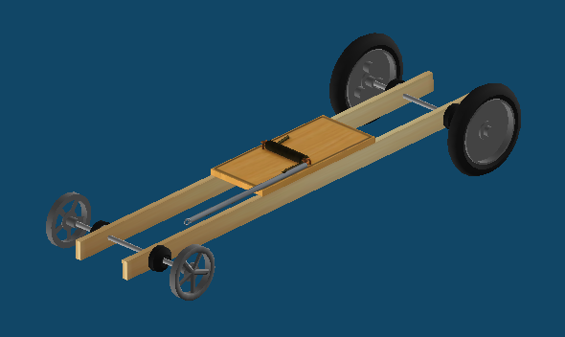 | 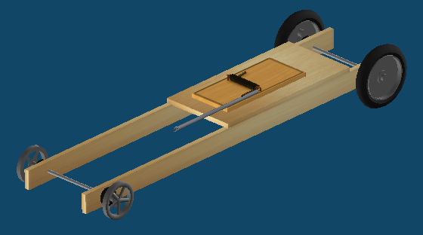 | 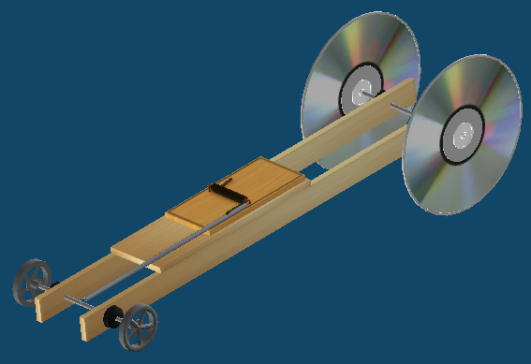

Final C.A.D. Model & Specifications
(Include screenshots from all angles of your final design model, plus copy the final design Spec’s from the Outputs tab and the virtual Competition results. )

Engineering Drawing
(Printed Directly from Outputs Tab. May need to save to flashdrive and print off from teacher’s computer.)

Construction of Prototype
(Here is where you describe the process of constructing your prototype model. Keep in mind that what you built in real-life probably is not identical with the virtual design you made, if only because we didn’t have all of the same materials. Discuss what materials you chose to use and why you chose those over other. What other changes or modifications from your original virtual design were you forced to make? For instance, some people had to shorten the frame or change the location of the axles after drilling the holes crooked the first time. What difficulties or challenges did you face and how did you deal with them? How did you anticipate those changes or problems may have affected your final model?)

Field Testing and Modifications
(After building the prototype model, you were asked to take it in the hallway and test it. What were the results of these early test? Describe what happened both in qualitative terms, meaning descriptive language, as well as quantitative numerical measurements, if possible. Did your real-world field testing match your online virtual testing? If not, why do you think that is? What did you do to improve the performance of your real-world prototype model? If it consistently steered to the left, what did you do to adjust it? Describe any and all modifications you made to the physical model, along with why you made them, after initially testing it.)

Conclusion
(This is the most important part of all. Start off by reminding the reader what the goal or objective of this project was. Then briefly, in only a sentence or two, summarize the main points of what you did to achieve this goal. Then, discuss the final results of your prototype testing. Did you meet or exceed the goal? Why, or why not, do you think? What could possibly be done to improve your current model further? What could have been done differently if we were to start the entire project over again? What were the biggest, most important lessons you learned from this project, and how can those lessons be applied elsewhere in life and/or school? Take your time with this section. Really reflect on this project and try to express all of your thoughts. If there is one part of the report to take more seriously than all of the others, this is it. It should probably be one of your longest and most well-developed sections. What do you want other people to know about this project, and what do you think you’ll remember or would want to remember 10 years down the road? Be sure to provide evidence or support based on observations or data for any statement you make about the Mousetrap Cars and what makes them work best.)

Appendix
(In addition to being an organ in the human body, an appendix is also defined as a section of additional materials and information that help to understand the information in a document, and it’s found at the very end. This is where you would attach your original notes you took from the Background Research, or where you’d include sketches and diagrams you made along the way. When you recorded data in your Science Notebook, those pages would get ripped out and stapled here. This is where we collect all of the “loose change” that doesn’t fit anywhere else in the project, but is still related.

