HOW TO USE THIS DOCUMENT:
Do not change the formatting (text, size, margins, etc.)
Leave everything that’s printed Black-on-White.
Everything in GREY, read carefully and follow its instructions.
Then delete the grey from the final draft.
Everything in YELLOW, change to match your personal data.
Delete the first 3 pages (everything before the Title Page) in your final draft.

Hello Discovery Students! This document is a template for how to write a formal Lab Report.
What’s a template?
It’s a model or an example to follow. College professors and even some High School teachers often have strict rules about how to write certain papers. For instance, many people require a special font or a specific amount of spacing in your document. This is called formatting, and in this template I’ve already set-up the most common, standard formatting: 1 inch margins all the way around the paper, double line spacing, and 12-point sized Times New Roman font. In a Prezi or PowerPoint presentation, you can usually change these things to make it look prettier, but when writing a special paper, it’s best to leave it the way your teacher wants. (Many professors will deduct points if your paper is not written with the required formatting!)
What do you mean by formal Lab Report? What makes a paper formal?
There are two kinds of writing: formal and familiar. Familiar (from the root word “family”) is the way you’d write a letter or a note to your friends or a family member. Your tone would probably be pretty friendly. The language you use might include slang words, maybe even a joke or two. You’d probably refer a lot to yourself (“I think… I saw… I went…”).
Formal writing, on the other hand, is like going to a formal restaurant for dinner; there are lots of rules. The tone, or mood, is very serious and straight-to-the-point. Jokes and asides are inappropriate in this type of writing, and it’s even encouraged not to use the word “I.” Instead, the passive voice is used, meaning “I conducted the experiment,” would be changed to “The experiment was conducted.” “I thought I needed to use a longer lever arm,” would be written as, “It was determined that a longer lever arm was needed.”
We’re going to practice writing a formal report for our Mousetrap Powered Vehicle project. As with all serious pieces of writing, we will start with a rough draft. Try to follow the rules explained above. But if you have trouble, prioritize getting your thoughts on paper. We will be peer-reviewing later and can make corrections and revisions then.

When you’ve finalized your report (after writing a rough draft, getting peer-reviewed, revising your writing, etc.) and you’re ready to print, these first two pages of explanation should not be included. The next page, the Title Page, is where your report should begin. Make sure to add your name to the Title Page.
- You’ll need to use WhiteboxLearning.com to retrieve a lot of your data.
- Refer to www.take-a-screenshot.org for help with getting pictures of your model.
- Finally, your classmates and Mr. Franklin are always invaluable resources. You just need to be Proactice in asking for assistance when you need it.
Good luck!

The Discovery School
Engineering Challenge
Mousetrap Powered Vehicle
Lab Report

YOUR NAME
GRADE 6? 7? 8?
DATE?
Table of Contents
Abstract ………………………………………………………………………………………… #?
Introduction …………………………………………………………………………………… #?
Objective ……………………………………………………………………………………… #?
Initial Brainstorming …………………………………………………………………………… #?
Background Research (“Knowledge At Work”) …………………………………………….… #?
Design Parameters & Specifications …………………………………………………………… #?
Development of Computer Aided Design Model ……………………………………………… #?
Iteration 1 ……………………………………………………………………………… #?
Iteration 2 ……………………………………………………………………………… #?
Iteration 3 ……………………………………………………………………………… #?
Iteration #? ……………………………………………………………………..……… #?
Summary of Design Evolution ………………………………………………………………… #?
Final C.A.D. Model & Specifications ………………………………………………………… #?
Engineering Drawing ……………………………………………………………………...…… #?
Construction of Prototype ……………………………………………………………………… #?
Field Testing and Modifications ………………………………………………………….….… #?
Conclusion ……………………………………………………………………………………… #?
Appendix ……………………………………………………………………………………… #?
Abstract
An abstract is like the “blurb” on the back of a book or novel – it’s there to briefly sum up the “story” and convince the audience to dive in and read the rest of it. It comes at the beginning of a report, just like a good “hook” should be at the beginning of a story to draw the reader in. But since an abstract covers everything in the entire report, it should always be written last, once every other part is complete.
The abstract is always pretty brief, usually just a paragraph or two. But it can be a challenge to write because you have to narrow down and distill only the most important points in the project. Usually, it looks something like this:
- A sentence or two describing the Purpose of the project. (The purpose is not the same thing as the goal/objective. By purpose, I mean, “What’s my motivation to read this whole big, long report? Why should I even care about this experiment and its results?”) Briefly describe the relevance of the project to school or life, more broadly. How could doing this experiment, or the results of this experiment, ever help anybody or be applied elsewhere?
- A sentence or two restating the Question or Problem. In an Engineering Project (as opposed to a regular, classic experiment) the question/problem is very closely related to the Goal/Objective. Essentially, the “question” of an Engineering Project is, “How can I engineering something to meet my Objective?” So you’ll want to describe the Goal/Objective in this section of the report. (Note: Everything doesn’t have to be in this exact order in the Abstract. It may make more sense, for example, to put the Question/Problem/Goal/Objective before the Purpose, and that’s fine.)
- A few sentences describing your Methods or Procedures. How did you go about solving the problem or engineering something to meet your goal? In this instance, we Brainstormed, did background research to learn about the important concepts in Physics related to our goal, use a Computer-Aided Design program (or “CAD” program, for short) to design and virtually test or initial models, before finally building a prototype, field testing it, and making modifications as necessary. You should tell me a little bit about each of these steps. In particular, you should tell me about what variables you found to be important and how they affected your overall design. (In this case, the variables you experimented with include all the materials used to build the Mousetrap Car, as well as their configuration or arrangement.) If you were going for distance, what specifically did you do to make your model as a good distance-traveler?
- A sentence or two describing the Results of your testing. You just described your model and how you arrived at that particular design. So, how’d it do? Did you reach the objective? Here’s where you should put your actual final number. How many meters did you travel? (You may need to convert from feet.)
- A sentence or two describing the final Conclusions from this project. Based on your results, what have you learned? Was your model and design indeed the optimal (best) model or design? If not, what would have improved it? What worked well and what didn’t? If someone in another class were to build a Mousetrap Powered Vehicle for distance, what would be your recommendations?
This is the only section of the report where I’ve written way more than you should! If you count up what’s described in the bullet points above, it only comes to between 7 to 12 sentences. An abstract should easily fit on one page, it not half a page! They’re typically less than 200 words. (To give you an idea, this is word 620 from the section title, “Abstract.”) If you need more guidance, check out http://www.sciencebuddies.org/science-fair-projects/project_abstract.shtml. The process for writing a Science Fair abstract is about the same as any other project.

Introduction
(The audience reading your report has no idea what your project is all about. They’ve never heard of or seen WhiteboxLearning. They may have never even see your car, or any other Mousetrap Car, for that matter. Pretend that you’re chatting with an elderly neighbor and they ask you what you’re working on in Science class. Give them a brief description, starting from the very beginning. What is the project all about? Why are we doing this, other than for a grade? How is building a model car relevant to the real world outside of our classroom? – P.S.: Delete this explanation in the Final Draft.)

Objective
(Objective just means “goal.” What was the primary goal of this project? What were you trying to do from the very beginning? This section can be short, but it needs to be precise. I’m looking for exact, specific details. – P.S.: Delete this explanation in the Final Draft.)

Initial Brainstorming
(In this section, you can tell me about your original ideas. When I first told you we were going to build cars out of Mousetraps, what did you envision? What kind of wheels did you see your car being made out of? What was the body of the car made from? Did it look like a car, or else what was different about it? Many students drew sketches in their notebooks, or sketched designs with their neighbors or partners, and this would be a fantastic place to include those. This is kind of like a hypothesis – an educated guess – but before the educated part, because Background Research comes next. I’m wanting to see how the Background Research changed your mind about how your car should be constructed. – P.S.: Delete this explanation in the Final Draft.)

Background Research (“Knowledge At Work”)
(Remember all those notes you took? I asked for a minimum of 3 for every section. Here is where you summarize those. You don’t need to copy every note. What you should do is read your notes and select the most important pieces of information that came in handy while designing your car. What were the major “takeaways” that you used? What were the main ideas and major concepts that we’ve been studying in class that would be important for your reader to know about if they’re really going to understand your car? – P.S.: Delete this explanation in the Final Draft.)

Design Parameters & Specifications
(This information is available on Whitebox. You can highlight, copy, and paste it all. Or, you can take a screenshot. But the reader needs to know what limitations you were working under before you started designing. If you include a table or chart, you should also include a brief description in words of what that chart says. Don’t make the reader search through every column and every row and interpret all that data. That’s your job. Tell them what numbers in there are the most important, and why are they so important? – P.S.: Delete this explanation in the Final Draft.)

Development of Computer Aided Design Model
Iteration 1
What is an iteration? An iteration is like a version. You’ve probably heard people talk about iterations before when you’ve updated a software program from version 1.0 to 2.0, or Windows 7 to Windows 8. Those are each iterations, or improved-upon versions of the same thing. When you’re engineering, you re-iterate, meaning you make newer and newer versions, better than the ones before. Each new and improved version is the next iteration of the same idea.
In this section, you’ll be walking us through each stage or phase in the development of your Whitebox model by showing to us and talking about each iteration, or version, that led you to your final product. Be sure to include:
- The name of each model version (For Example: “Iteration 1: FranklinCar1.0, Iteration 2: FranklinCar2.0, Iteration 3: FranklinCar2.1, indicating only a minor change – use whatever names
you gave your models in Whitebox)
- A picture “screenshotted” or “snipped” from Whitebox.
- Design Specifications (available from the Outputs tab)
- The 3 data analysis graphs (Mass, Surface Friction, & Powertrain) – Be sure we can read them all!
- The results of Competition (“screenshotted” from the end of the race – we only need YOUR car, not your competitor’s)
- A brief description of your observations and conclusions about this model
- Your hypothesis or idea for improving upon it in the next iteration

See the next page for an example to follow:
Iteration 1: “FranklinCar1.0”
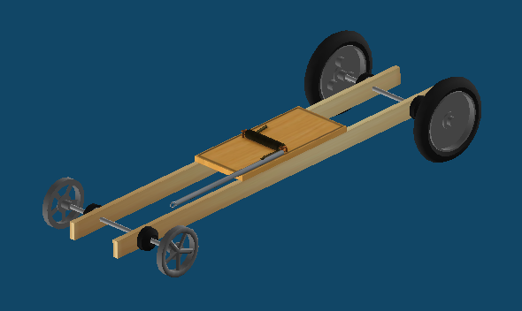
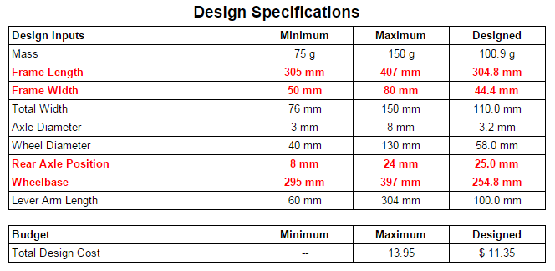

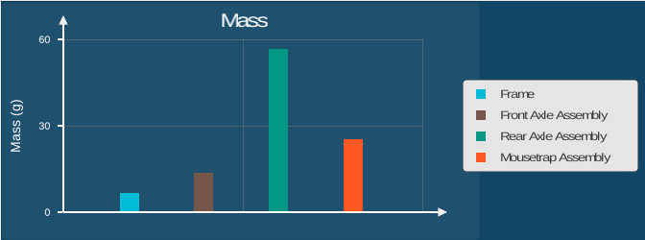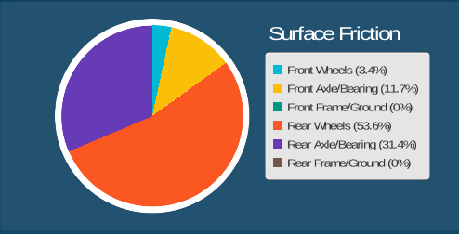
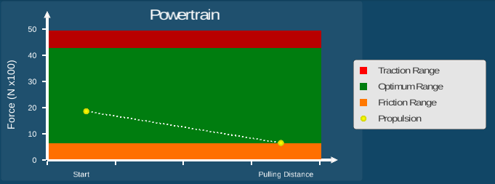

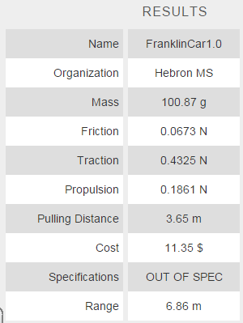

Analysis:
As you can see from the results of the race, the first iteration model did not perform very well. It went only 6.86 meters while the required minimum distance is 12.00 meters. That means FranklinCar1.0 is about 5.14 meters short of the goal.
Additionally, looking at the Design Specifications, it is clear that at least 4 parameters have not been met (indicated by the red text). The length and width of the frame and well as the Rear Axle Position and Wheelbase are all out of spec. In the next iteration, the first thing that will need to be done is to adjust all the variables to bring the car into spec.
Since the frame dimensions are both below the minimum allowed, they will both be increased to meet the minimum specifications. Meanwhile, the Rear Axle Position is over the maximum, so it will be brought down to the maximum allowable number. Finally, the wheelbase itself is too small. It will be increased.
However, looking at the Data Analysis graphs, there appear to be other problems with the back wheels. For instance, the bar graph showing Mass indicates the Rear Axle Assembly is contributing the most weight to the car, overall. That likely explains why there’s so much friction on the rear wheels in the Friction Pie Chart (over 50%) and why the Powertrain line graph shows the propulsion heading dangerously into the Friction Range.
Therefore, in the next iteration, the rear wheels and axle were replaced with a lighter option in hopes of decreasing the mass and, consequently, decreasing the friction.

Iteration 2

Iteration 3

Iteration #?

Summary of Design Evolution
(In the previous section, you demonstrated the changes you made from one iteration to the next.
Here, you will summarize those changes in a convenient overview for the reader using diagrams,
data tables, and descriptions. An exemplar may be found below.)

FranklinCar1.0 | FranklinCar2.0 | FranklinCar3.0
 | 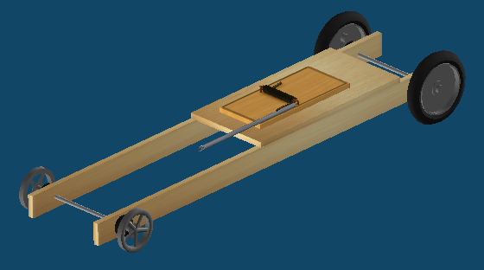 | 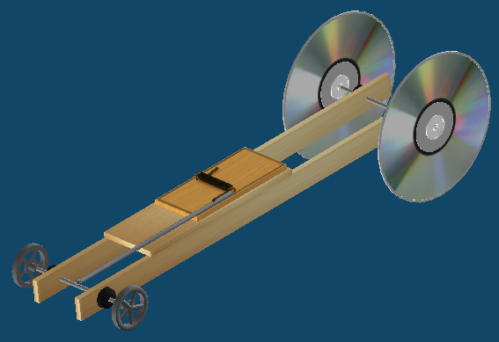

Final C.A.D. Model & Specifications
(Include screenshots from all angles of your final design model, plus copy the final design Spec’s from the Outputs tab and the virtual Competition results.)

Engineering Drawing
(Printed Directly from Outputs Tab.)

Construction of Prototype
(Here is where you describe the process of constructing your prototype model. Keep in mind that what you built in real-life probably is not identical with the virtual design you made, if only because we didn’t have all of the same materials. Discuss what materials you chose to use and why you chose those over other. What other changes or modifications from your original virtual design were you forced to make? For instance, some people had to shorten the frame or change the location of the axles after drilling the holes crooked the first time. What difficulties or challenges did you face and how did you deal with them? How did you anticipate those changes or problems may have affected your final model?)

Field Testing and Modifications
(After building the prototype model, you were asked to take it in the hallway and test it. What were the results of these early test? Describe what happened both in qualitative terms, meaning descriptive language, as well as quantitative numerical measurements, if possible. Did your real-world field testing match your online virtual testing? If not, why do you think that is? What did you do to improve the performance of your real-world prototype model? If it consistently steered to the left, what did you do to adjust it? Describe any and all modifications you made to the physical model, along with why you made them, after initially testing it.)

Conclusion
(This is the most important part of all. Start off by reminding the reader what the goal or objective of this project was. Then briefly, in only a sentence or two, summarize the main points of what you did to achieve this goal. Then, discuss the final results of your prototype testing. Did you meet or exceed the goal? Why, or why not, do you think? What could possibly be done to improve your current model further? What could have been done differently if we were to start the entire project over again? What were the biggest, most important lessons you learned from this project, and how can those lessons be applied elsewhere in life and/or school? Take your time with this section. Really reflect on this project and try to express all of your thoughts. If there is one part of the report to take more seriously than all of the others, this is it. It should probably be one of your longest and most well-developed sections. What do you want other people to know about this project, and what do you think you’ll remember or would want to remember 10 years down the road? Be sure to provide evidence or support based on observations or data for any statement you make about the Mousetrap Cars and what makes them work best.)

Appendix
(In addition to being an organ in the human body, an appendix is also a section in the back of some documents and books that contains additional materials and information that help to understand the subject. This is where you would attach your original notes that you took on notebook paper, for example, or where you might want to include sketches and diagrams you drew throughout the project. When you recorded data and observations during testing, again, those pages should be pasted here. This is where you collect all of the “loose change” that doesn’t fit anywhere else in the project, but is still relevant.

