Development of Computer Aided Design Model
Iteration 1
( What is an iteration? An iteration is like a version. You’ve probably heard people talk about iterations before when you’ve updated a software program from version 1.0 to 2.0, or Windows 7 to Windows 8. Those are each iterations, or improved-upon versions of the same thing. When you’re engineering, you re-iterate, meaning you make newer and newer versions, better than the ones before. Each new and improved version is the next iteration of the same idea.
In this section, you’ll be walking us through each stage or phase in the development of your Whitebox model by showing to us and talking about each iteration, or version, that led you to your final product. Be sure to include:
- The name of each model version (For Example: “Iteration 1: FranklinCar1.0, Iteration 2: FranklinCar2.0, Iteration 3: FranklinCar2.1, indicating only a minor change – use whatever names
you gave your models in Whitebox)
- A picture “screenshotted” or “snipped” from Whitebox.
- Design Specifications (available from the Outputs tab)
- The 3 data analysis graphs (Mass, Surface Friction, & Powertrain) – Be sure we can read them all!
- The results of Competition (“screenshotted” from the end of the race – we only need YOUR car, not your competitor’s)
- A brief description of your observations and conclusions about this model
- Your hypothesis or idea for improving upon it in the next iteration

See the next page for an example to follow:
Iteration 1: “FranklinCar1.0”
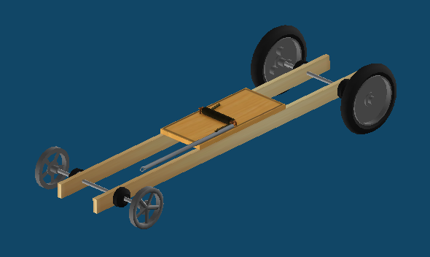
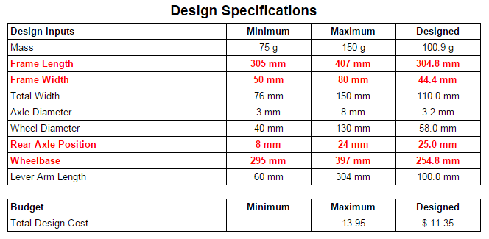

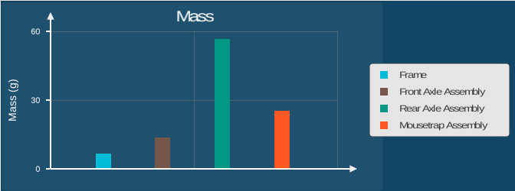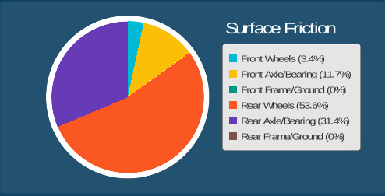
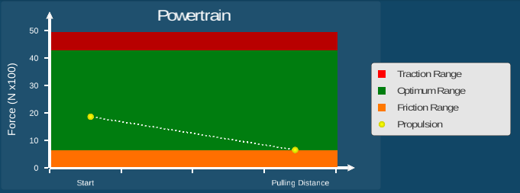

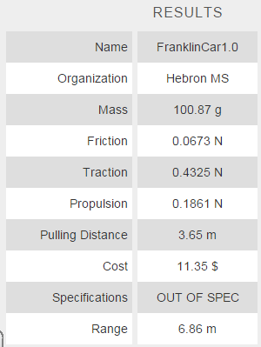

Analysis:
As you can see from the results of the race, the first iteration model did not perform very well. It went only 6.86 meters while the required minimum distance is 12.00 meters. That means FranklinCar1.0 is about 5.14 meters short of the goal.
Additionally, looking at the Design Specifications, it is clear that at least 4 parameters have not been met (indicated by the red text). The length and width of the frame and well as the Rear Axle Position and Wheelbase are all out of spec. In the next iteration, the first thing that will need to be done is to adjust all the variables to bring the car into spec.
Since the frame dimensions are both below the minimum allowed, they will both be increased to meet the minimum specifications. Meanwhile, the Rear Axle Position is over the maximum, so it will be brought down to the maximum allowable number. Finally, the wheelbase itself is too small. It will be increased.
However, looking at the Data Analysis graphs, there appear to be other problems with the back wheels. For instance, the bar graph showing Mass indicates the Rear Axle Assembly is contributing the most weight to the car, overall. That likely explains why there’s so much friction on the rear wheels in the Friction Pie Chart (over 50%) and why the Powertrain line graph shows the propulsion heading dangerously into the Friction Range.
Therefore, in the next iteration, the rear wheels and axle were replaced with a lighter option in hopes of decreasing the mass and, consequently, decreasing the friction.

